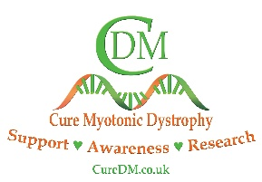
NAME
My Specialists Team contact details

Area of care and contact details | Name Specialist | Frequency of visits | Date last seen
EXAMPLE  Neuromuscular Consultant  Royal Left Hospital (RLH)  0100 101 202  M.white@rlh.uk | EXAMPLE  Dr M White – Consultant  E High – Physiotherapist  B Clarke – Neuromuscular Nurse | EXAMPLE  Yearly review at RLH | EXAMPLE  Last seen January 2025

Include all current health professionals involved in your care. These might include personnel from your Neuromuscular team, Physio, OT, Dieticians, Paediatrician, GP, SALT team, Cardiology or Respiratory consultant, etc.

