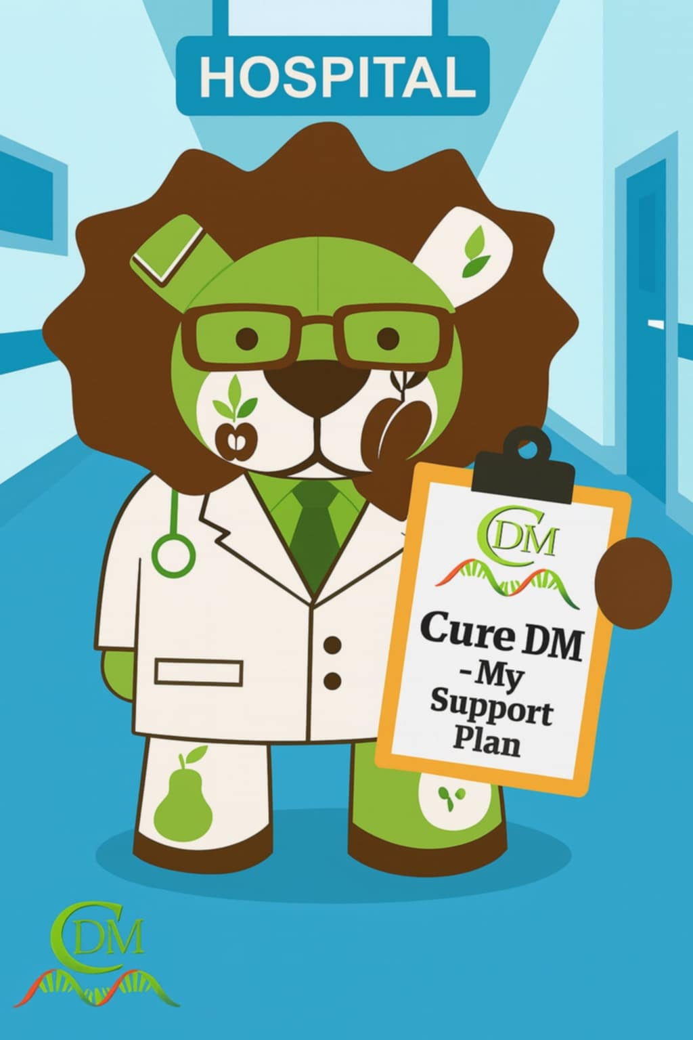

My name is:

My condition is:

Thank you for reading my DM support plan
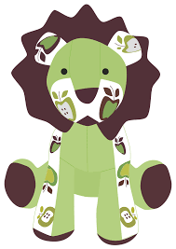

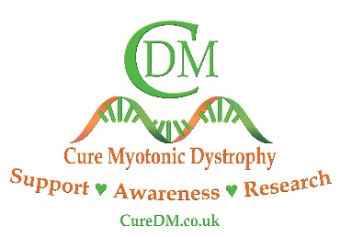
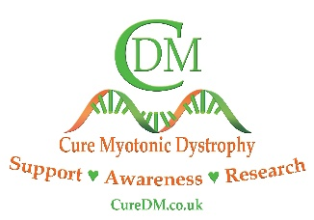

Up to date picture
Name Pen Picture
Last updated – dd/mm/yyyy
L

PRIVATE & CONFIDENTIAL
Authorised Use by Carers, Family & Health professionals ONLY
Visit www.curedm.co.uk for more information

Name:

Date of Birth:

Contacts: Include contacts of everyone to be contacted in an emergency, including phone number and relation (e.g. mum, dad, aunties, friends, PA). You can include specific hospital information here too.

Medical: Include medical professionals to be contacted, including neuromuscular team or any other relevant healthcare professionals. (Hospital, address, phone and email if known.)
Write a simple sentence about the person, keep it short and to one line.

Strengths, Interests & Hopes
Make this about the person as an introduction before condition. What they like doing when they are well and what helps them to have a good day. Include things such as special toys or interests, and a guide of what they can do with support.

NAME OF CONDITION (Congenital Myotonic Dystrophy, Myotonic Dystrophy Type 1/Type 2)
DM is multi-systemic & life-limiting, the main serious problems being respiratory & cardiac. It is a progressive, degenerative muscle wasting disease that affects the whole body, including the central nervous system and cognition. Symptoms I currently show are: Include ones which are specific to the person and describe next to each one the specific symptoms and how they are affected. Some common ones to consider are: Muscular, Learning Difficulties, Autism, Speech, Swallowing, Sensory, Toileting/Gastro, Sleepiness, Cardiac, Respiratory, Hearing or Sight.

Fears, Challenges & Dislikes
This can be in simple and easy to read bullet points. Include information you think is vital health professionals are aware of and will ensure they receive the best and most personalised care. Including information such as sensory issues, emotional regulation, communication problems.

Things That Help
Put these as simple and easy to read bullet points. Make sure these are specific and personalised to the person being cared for. Include information about day-to-day life, what helps and what they might need more of if they are poorly or in a medical situation. Think about physically, emotionally, and personally.

Diet
Include any information about their diet including aversions, allergies, preferences and also method of feeding where necessary. Highlight risks such as choking or aspirations. Always be clear and concise and don’t leave things to interpretation.

Medical
This is a very important section. Please include detailed information regarding medical treatment specific to the person. This can include the severity in which the person suffers with the condition and highlight key things that they may specifically struggle with. Don’t shy away from the complexity of the condition and remember you are the experts of your own situation. Include allergies, previous reactions to certain medications or medications that may help. Highlight again the contact details for specific healthcare professionals where necessary and a list of all current medication. You can add links to other medical records you have here (see swallowing plan, etc)

CureDM - It is important to remember that this form can be used for emergency medical interventions but also can be used when attending first appointments with new healthcare providers. It is helpful to have a copy in meetings, at schools and colleges, or for family and friends. This profile is not just about the condition, but the PERSON too, and it should highlight key facts with focus on the person being cared for, and HOW it affects THEM. Ensure to have up-to-date details for your medical specialists so they are contactable when needed. If you need any advice or have any questions relating to this pen profile form, please contact the Charity and we will be happy to help. We recommend you update the form regularly as things change.

